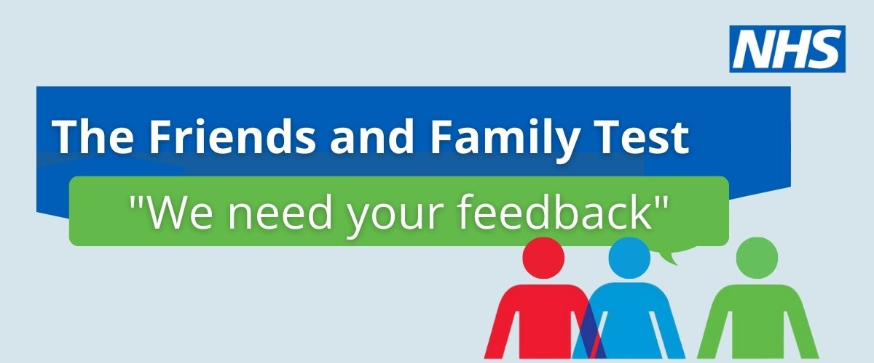
Results for our Friends and Family Test for August 2026
Our results for this month as follows:
95% of users would find our service very good or good!!
Please assist us to improve our service by contacting the surgery with your comments
Email - GP.N84005@nhs.net

