|  |  |
| --- | --- |
|  |  |
|  |  |
|  |  |

Dear Parent/guardian

Your child’s annual flu vaccination is now due

Flu can be a horrible illness and can sometimes cause serious complications. **Children under the age of five years have the highest rate of hospital admissions due to flu.**

Last winter over 10,000 children were admitted to hospital due to flu. Evidence shows that the flu vaccine reduced the risk of being admitted to hospital.

Vaccinating your child will also help protect more vulnerable friends and family by preventing the spread of flu. With COVID-19 still in circulation it is very important to reduce the number of those becoming ill with flu this winter to help protect them and the NHS.

The vaccination is a **free**, **safe, quick and painless** spray up the nose. If your child is unable to have the nasal spray an injectable alternative is available.

## I recommend your child has the flu vaccination.

**Please phone 01704 501500 to book an appointment for your child’s flu vaccination.**

Yours sincerely,

Drs Roseberry, Irvine, Speed, Selvarajah & O’Hara

Further information about the flu vaccine is available from your GP, pharmacist, health visitor or visit [www.nhs.uk/flu](http://www.nhs.uk/flu).

For information about the flu vaccine in different languages visit [Flu vaccination for children: leaflets and posters - GOV.UK (www.gov.uk)](https://www.gov.uk/government/publications/flu-vaccination-leaflets-and-posters)



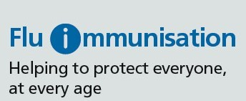

**All about flu and how to stop getting it**

# 1 2 3

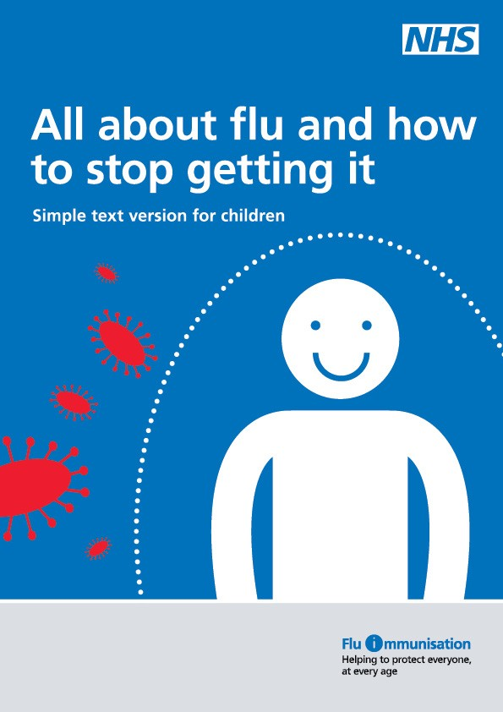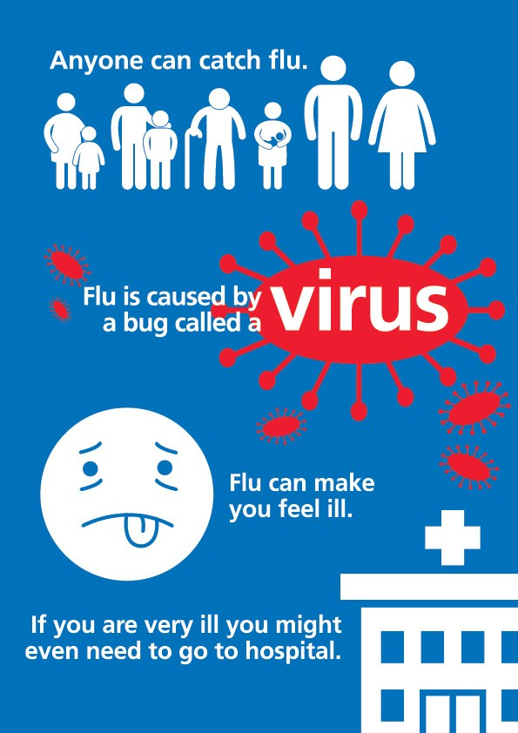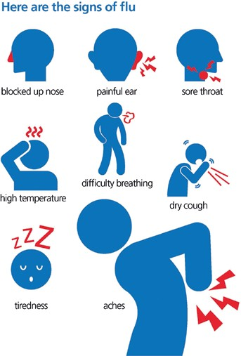

**4 5 6**

