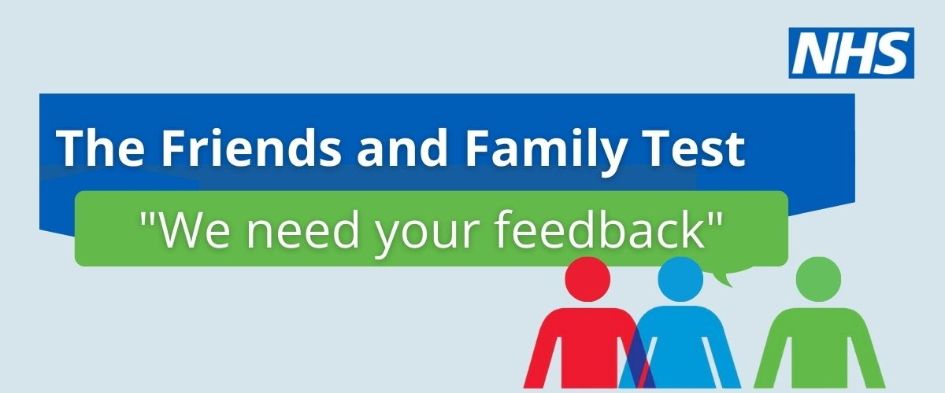
Results for our Friends and Family Test for March 2026
Our results for this month as follows:
85% of users would find our service very good or good
Please assist us to improve our service by contacting the surgery with your comments
Email N84005@nhs.net

